Name (in English): __________________________ Student ID number:

Score: ____________________ / 100

**Laboratory # 1 Resistive Networks**

**EE188L Electrical Engineering I**

NAU + CQUPT (Fall 2020)

# Objectives

1. Learn to determine a resistor’s value and tolerance from its color code and by measuring its value with the DMM.
2. Learn how to use a Protoboard to construct a circuit.
3. Identify current flow through components in various resistive circuits
4. Identify series and parallel connections of resistors
5. Calculate and measure equivalent resistance of series and parallel resistors
6. Determine circuits with maximum and minimum resistance, along with properties of voltages and currents in them.

Grading:

|  |  |
| --- | --- |
| Activity #1 _____________ / 20 | Activity #3 ___________ / 60 |
| Activity #2 _____________ / 20 |  |

**Important Concepts:**

1. A test bench is used to power and measure electrical circuits. Each test bench in the laboratory contains a DC power supply, digital multimeter (DMM), oscilloscope, Protoboard, function generator, and computer.
2. The color code on a resistor specifies its intended (or nominal) value at room temperature and its tolerance (or how far off the true value might be).
3. The equivalent resistance is found by combining resistors together in series or parallel.
4. Resistors all in series produce maximum resistance and resistors all in parallel produce minimum resistance

**Special Resources**:

1. The PowerPoint file “Lab 2 Photos.ppt” is available in Bb Learn.

**Activity #1: Resistance Color Codes and Measurement**

The Digital Multimeter, or DMM, is used to make voltage, current or resistance measurements. This activity will use the DMM to measure resistance.

1. Get 4 resistors, 2 of one color code (or value) and 2 of a second color code (or value), in the range of 1 KΩ to 5 KΩ from the supply cabinet.
2. Note the color code and nominal value of all 4 resistors using the resistor color code and record each value in **Table 1**. Measure each resistor’s value with the DMM and record in the next column of the same table. See “Lab 2 Photos.ppt” for how to measure resistance.
3. Calculate the % Error for each resistor using this formula:

% Error = 100% * (Measured Value - Nominal Value) / Nominal Value

|  |  |  |  |  |
| --- | --- | --- | --- | --- |
| **Table 1. Resistor Values** | | | | |
|  | Color Code | Nominal Value | Measured Value | % Error |
| R1 |  | 2k |  |  |
| R2 |  | 3.9k |  |  |
| R3 |  |  |  |  |
| R4 |  |  |  |  |

1. Resistors are normally sold as 1%, 5%, or 10% as indicated by the last color band, meaning the actual value should have an X% error or less than that specified. From your small sample, how many of your resistors are not within tolerance, barely within tolerance, or well within tolerance?

# Activity #2: Introduction to the Protoboard

The Protoboard is a handy device for wiring circuits. Some may have built-in power supplies and all have holes for plugging in devices like resistors, capacitors, and integrated circuits and to make interconnections with wires.

1. In our lab, the Protoboard does NOT have built-in dc power supplies. So connect the +5 and -5Volts dc power from the lab power supplies to the protoboard. Record the exact **nominal** values of the power supplies in Table 2.
2. Calculate and record the % Error for each voltage source as

% Error = 100% * (Measured Value - Nominal Value) / Nominal Value

**Table 2. Protoboard DC Power Supplies**

|  |  |  |
| --- | --- | --- |
| **Nominal Voltage** | **Measured Voltage** | **% Error** |
|  |  |  |
|  |  |  |
|  |  |  |

The Protoboard is used to breadboard circuits and many of the connections are made underneath the holes on the Protoboard.

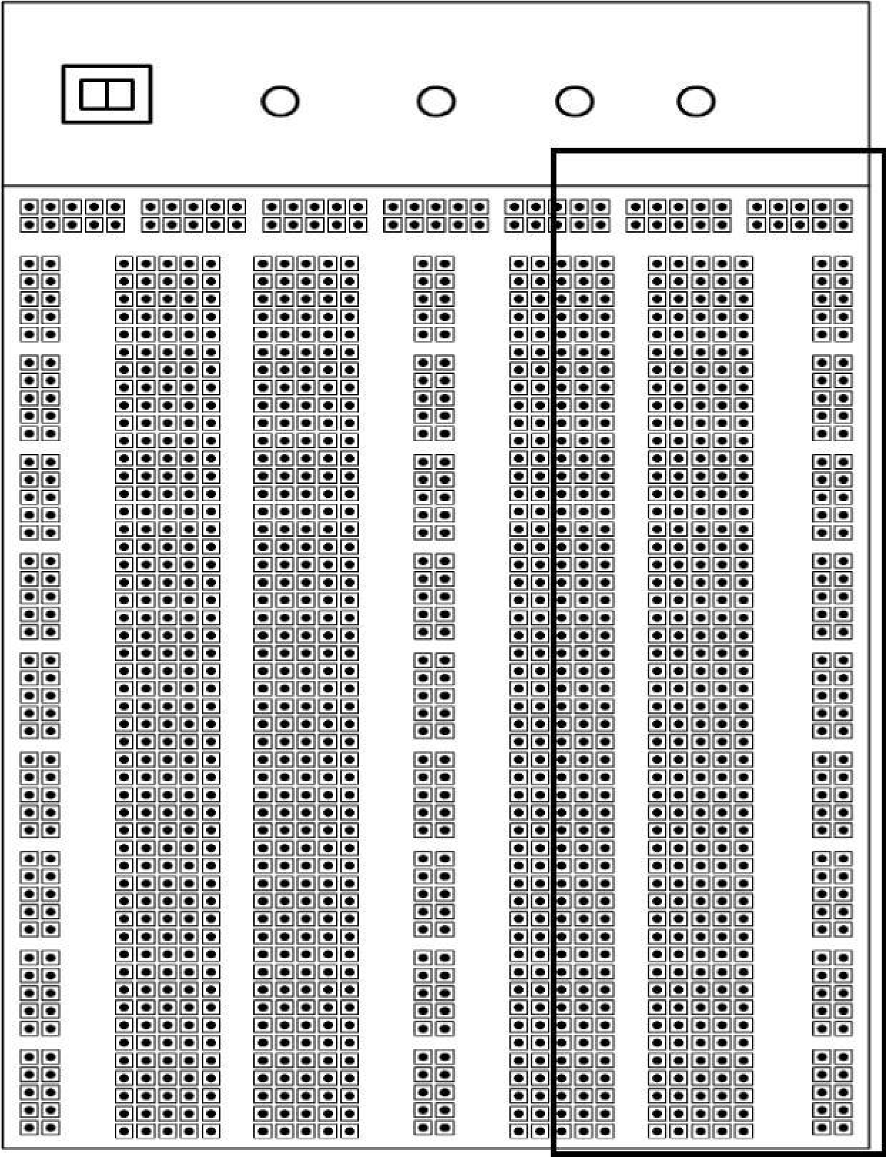Note that the rows and columns on the Protoboard are composed of sets of 5 holes. Each hole in a set of 5 holes are connected together. Also, some sets of 5 holes are connected to other sets.

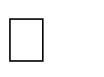Use the DMM to measure resistance in order to determine the connection patterns for all the holes on the Protoboard. Note that a connection will measure as nearly 0 while no connection will measure as an open circuit (OL or very large). You can insert a short wire into a hole in order to access each connection hole.

In the figure on the right, **draw a few lines (not too many!) between all sets of holes that are connected in the area highlighted.**

# Activity #3: Series and Parallel Resistors

1. Resistors can be connected in series or in parallel. In the circuits A through E shown below, assume that a voltage source is connected between nodes A and B and trace the current flow for each resistive network. (Trace all possible paths from A to B)

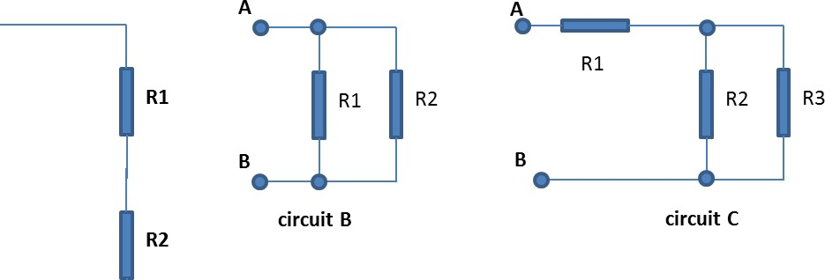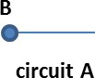

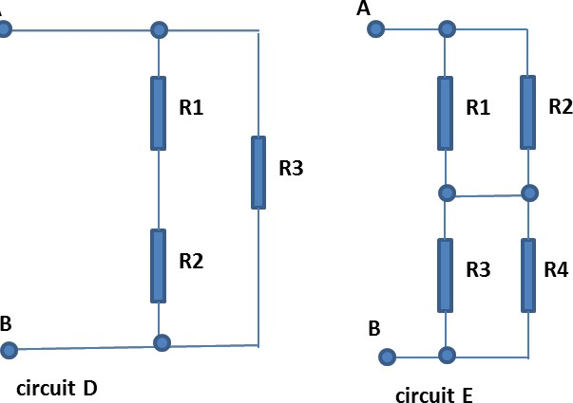

**Activity #3: Series and Parallel Resistors: Calculations and Measurements**

Resistors connected in series have an equivalent resistance given by:

𝑅𝑒𝑞=𝑅1+𝑅2+⋯+𝑅𝑛

Resistors in parallel have an equivalent resistance given by:

# 𝑅𝑒𝑞

𝑅1∗𝑅2 For two resistors this can be written as: 𝑅𝑒𝑞 =

𝑅1+𝑅2

(Note: do not make the mistake that this formula will hold for three or more resistors. Req does not equal the product of the three or more resistors over their sum.)

1. Show the formula you would use and calculate the equivalent resistance between points **A** and **B** for each circuit. Fill in the values in **Table 3 with values from activity 1**.

Circuit A: Req = __________________________________________

Circuit B: Req = _____________________________________________

Circuit C: Req = _____________________________________________

Circuit D: Req = ____________________________________________

Circuit E: Req = _____________________________________________

|  |  |  |  |
| --- | --- | --- | --- |
| **Table 3: Series and Parallel Resistors** | |  |  |
|  |  |  | Req |
|  | Calculated |  | Measured |
| Circuit A |  |  |  |
| Circuit B |  |  |  |
| Circuit C |  |  |  |
| Circuit D |  |  |  |
| Circuit E |  |  |  |

1. Now build circuits **A–D** and measure the equivalent resistance between points **A** and **B** for each circuit using the DMM. Fill in the values in **Table 3**. Do the measured values agree with your calculation? They should agree closely, so go back and determine where you made either a calculation error or measurement error and make the correction.
2. Build circuits **E** and measure the equivalent resistance between points **A** and **B** using the DMM. Fill in the value in **Table 3**.
3. What is the **maximum** equivalent resistance that you can get with your **four resistors**? _________________ The **minimum?** _____________________
4. Draw the circuits below. Be sure to label R1, R2, R3 and R4.

**Maximum Req Minimum Req**

|  |  |  |
| --- | --- | --- |
|  |  |  |

1. a) First, build the **maximum resistance** circuit. **Before connecting the 5v** **supply**, measure the equivalent resistance. Req (max) = _______________

Connect your circuit to the +5v supply; one end of the circuit should be connected to the +5v terminal and the other end to the reference connector. Measure the voltage across each resistor and enter the values into **Table 4** along with the measured values of each resistor from **Table 1**.

b) Next, build the **minimum resistance** circuit and **disconnect the 5v supply**.

Measure the equivalent resistance. Req (min) = ______________________ Connect your circuit to the +5v power supply; one end of the circuit should be connected to the +5v terminal and the other end to the reference connector.

Measure the voltage across each resistor and enter the values into **Table 4** below.

|  |  |  |  |  |
| --- | --- | --- | --- | --- |
| **Table 4: Resistor Voltage Measurements** | | | | |
| Resistance | |  | Voltage | |
| Value | |  | Maximum Resistance Circuit | Minimum Resistance Circuit |
| R1 |  | VR1 |  |  |
| R2 |  | VR2 |  |  |
| R3 |  | VR3 |  |  |
| R4 |  | VR4 |  |  |
|  |  |  |  |  |

1. For the **maximum equivalent resistance** circuit,

|  |
| --- |
| a) What did you notice about the voltage across each resistor in each pair? |
| b) Which resistor had the highest voltage and which had the lowest voltage? |
| c) The current supplied by the 5-volt source can be calculated using Ohm’s Law, Isource = 5/Req. Calculate Isource. Be sure to include units.  Isource = __________________ |

1. For the **minimum equivalent resistance** circuit,

|  |
| --- |
| a) What did you notice about the voltage across each of the resistors, even though they all did not have the same resistance value? |
| b) If Current = Voltage/Resistance by Ohm’s Law, which resistor(s) had the highest current and which had the lowest current? |
| c) Using Ohm’s Law, calculate the 4 currents through the resistors, add them together and compare them with Isource=5 volts/Req. |

1. Which circuit drew the highest current from the source and why?
2. Which circuit drew the lowest current from the source and why?

**IMPORTANT: Get the instructor’s signature below. No signature, no marks!!**

**Instructor signature _____________________ Date ___________________**